TASK 7 – Evaluate Process Control System Calls
1. Aim
To understand how a command shell creates, executes, and manages processes using fork(), exec(), wait(), and exit(), and to evaluate alternative methods such as posix_spawn() and threads.
2. Explanation of Process Control System Calls
a) fork()
- fork() creates a new process called the child process.
- The process that calls fork() is called the parent process.
- The child receives a copy of the parent's process state and continues execution from the statement after fork().
- The return value is:
  - 0 in the child process.
  - Child's process ID in the parent process.
  - -1 if process creation fails.
- Modern operating systems generally use copy-on-write (COW), so memory pages are initially shared rather than immediately copied.
b) exec()
- The exec() family replaces the current process program with a new program.
- It does not create another process.
- The process ID usually remains the same.
- If exec() succeeds, the statements after it do not execute.
- If it fails, it returns -1.
In this assignment, execlp() searches for the expr command in the system's PATH and executes it with the arguments 6, *, and 7.
c) wait() and waitpid()
- wait() makes the parent wait until one of its child processes terminates.
- waitpid() allows the parent to wait for a specific child process.
- The child's termination status is collected by the parent.
- This prevents the completed child from remaining as a zombie after its status is collected.
d) exit()
- exit() terminates the current process normally.
- It flushes standard I/O buffers and performs normal C library cleanup.
- The exit status is made available to the parent through wait() or waitpid().
_exit() terminates immediately without flushing C standard I/O buffers. It is commonly used in a child process when exec() fails.
3. How a Shell Executes a Command
A command shell manages programs using the following sequence:
- The user enters a command.
- The shell calls fork() to create a child process.
- The child calls an exec() function to replace itself with the requested command.
- The operating system executes the new program.
- The parent shell calls wait() or waitpid() for a foreground command.
- The child terminates and provides an exit status.
- The shell collects the status and displays the next prompt or continues processing.
4.C Program – fork(), execlp() and waitpid()
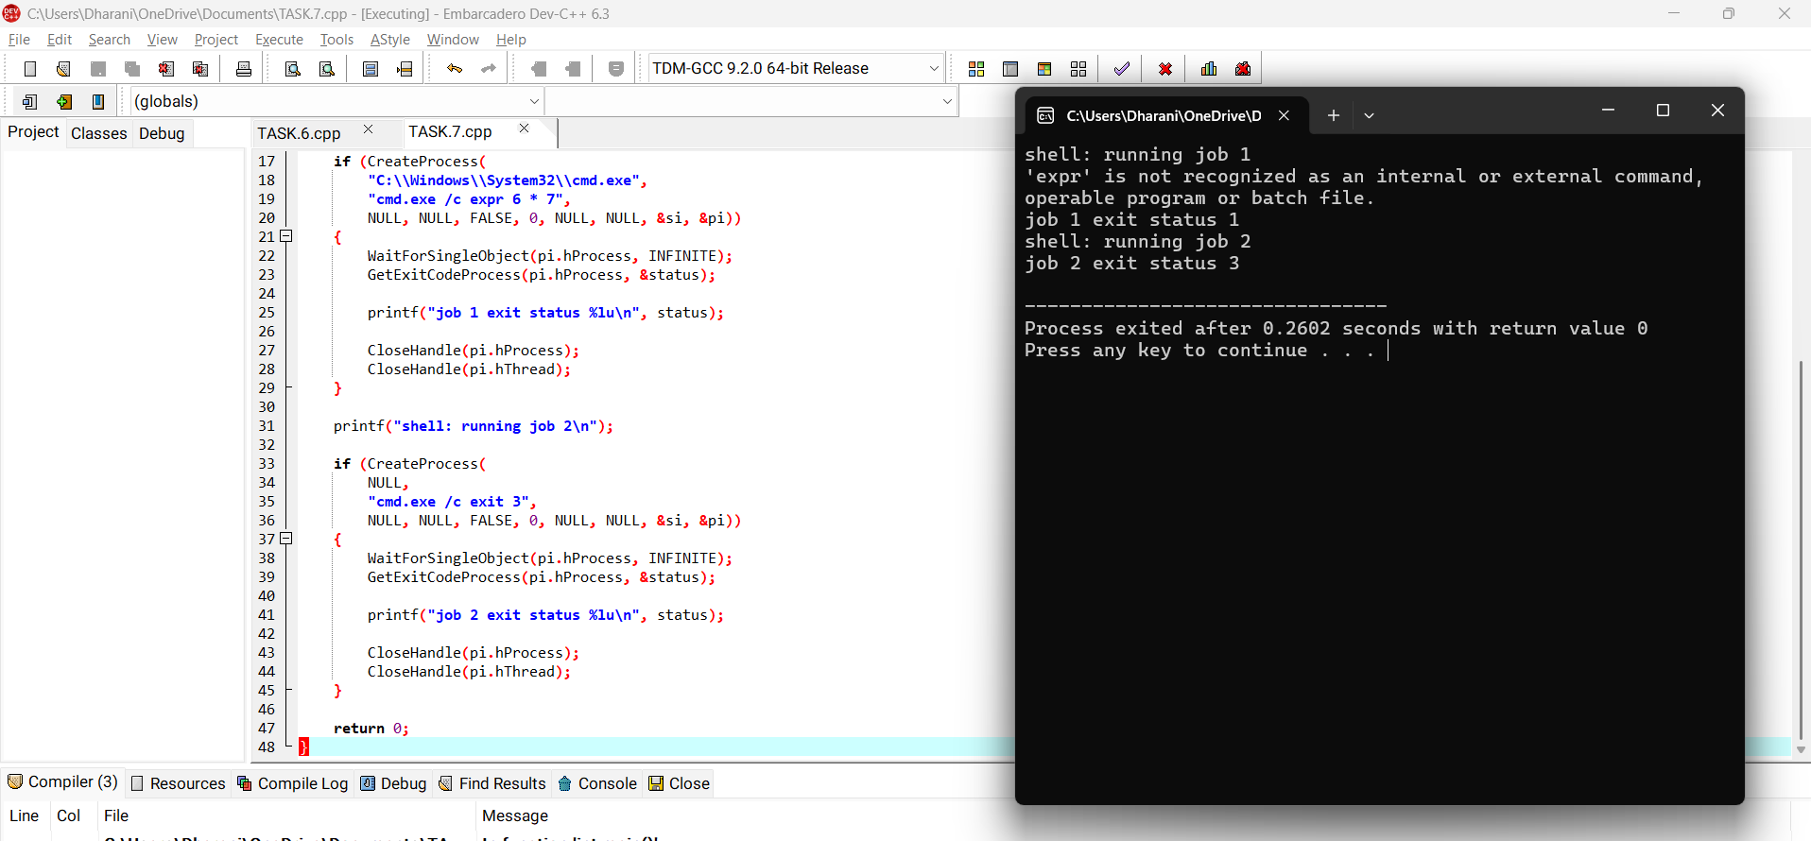

Compare memory usage and isolation between processes and threads.
Factor | fork() + exec() | posix_spawn() | Threads
Memory | Uses copy-on-write initially | Separate process memory | Shared memory
Creation time | Generally higher | May be lower | Generally lower
Isolation | Strong | Strong | Limited
Resource sharing | Limited | Limited | High
Failure impact | Usually affects one child | Usually affects one child | Can affect the entire process

Conclusion:
Process control system calls help the operating system create, execute and manage programs efficiently. fork(), exec() and waitpid() allow a shell to manage independent commands and collect their exit statuses. posix_spawn() offers an alternative process-launching method, while threads are useful for shared-memory parallel execution.

